


April 1, 2025
FOR IMMEDIATE RELEASE

WARMAN CITY COUNCIL APPROVES OFF-LEASH CAT PARK
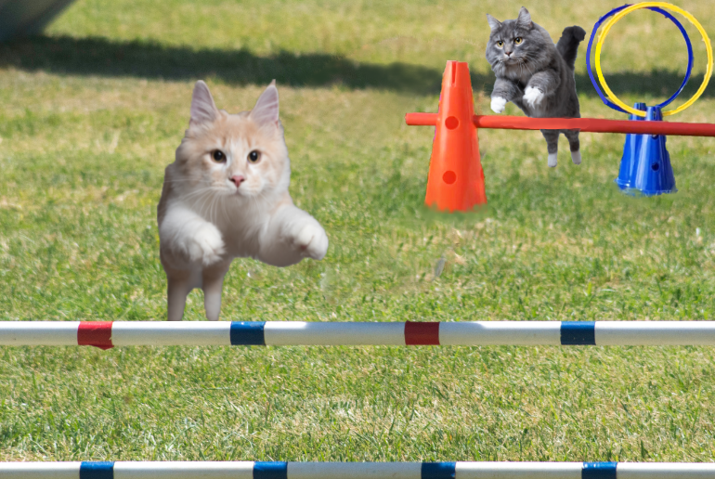
The City of Warman will be home to the very first Off-Leash Cat Park in Saskatchewan. Warman City Council unanimously approved the park which will replace the ball diamond in
the southwest corner of Prairie Oasis Park.

"Although Warman has been chosen by Softball Canada to host the U17 Girls National Championship this summer, we are confident that the removal of one of the six diamonds at Prairie Oasis will not affect our ability to host the event," says Mayor Gary Philipchuk. "It is also very exciting for me to be able to take my cats, Ebony and Ivory, to a place where they can run around and play with other cats after they wake up from their 12-hour naps."

The Warman Off-Leash Cat Park will be complete with an obstacle course, several scratching posts, catnip filled toys and large catnip plants, balls and toy mice with bells in them, string toys, dozens of cardboard boxes of varying sizes and several litter boxes.

- more -

City of Warman Recreation and Culture Lead, Councillor Chris Mason, says, "The public spoke, and we listened. Although this is my first term on Council, my veteran fellow Councillors have assured me that the residents of Warman have been very vocal over the past several years regarding the need for a cat park."

Planning, Development and Transportation Lead, Councillor Marshall Seed, strongly approves the location of the new park. "We hired a pedologist to study the soil of several locations in Warman and the results showed that the best and softest soil was where our world class ball diamonds are located. After that, the decision was easy. Council agreed that the felines deserve the best."

The demolition of the southwest corner ball diamond at Prairie Oasis Park will begin in early May and will be followed by landscaping and the laying of sod for the Off-Leash Cat Park.

- 30 –

For more information, media inquiries and interview requests, please contact:
Andy Szachlewicz
Communications Liaison & Executive Assistant - City of Warman
execassistant@warman.ca
306-385-2328 (office)

