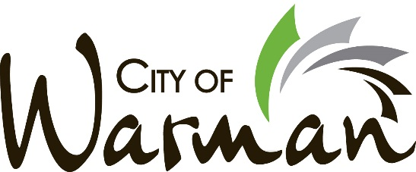


MARCH 11, 2025
FOR IMMEDIATE RELEASE

The City of Warman announces that Doug Ramage has decided to step down from the position of City Councillor with the City of Warman. Citing family reasons, Doug presented his resignation at the Regular Meeting of Council on Monday, March 10th, 2025.

In his role as Councillor, Doug Ramage proved to be a valuable and instrumental asset to the City.
His passion and unrelenting drive for what is good and right for the City of Warman was often displayed as he advocated for more health care and proactively shared his knowledge and gave solid guidance in the area of engineering. We thank Doug for his contributions in asset management, protections and economic development, and we thank him for his commitment and time with City Council.

Doug is a father, a hockey coach and a proud resident of Warman who has volunteered many hours in the community. The City of Warman thanks Doug Ramage for his contributions and dedication to Warman City Council and to the municipality, and we wish him the best of luck in all of his future endeavours.

The City of Warman will be hosting a by-election, to fill the newly vacated City Councillor position, at a soon-to-be determined date.

- 30 -

For more information, media inquiries and interview requests, please contact:

Andy Szachlewicz
Communications Liaison & Executive Assistant
City of Warman
execassistant@warman.ca
306-385-2328 (office)

